Flight Reservation system
Aim: To Develop a Flight Reservation system by using Zoho -CRM
https://creatorapp.zoho.in/https://github.com/raghu337/Cloud-computing-CSA1527

Procedure:
- Create an organization in Zoho IAM.
- Define three user roles: Admin, Customer, and Airline Staff.
- Create separate pages for Admin, Customers, and Airline Staff.
- Assign access permissions to each role using Zoho IAM.
- Allow Admin to add, update, and remove flight details.
- Allow Customers to search flights and book tickets.
- Allow Airline Staff to manage seat availability and flight status.
- Ensure each user role can access only its own dashboard and features

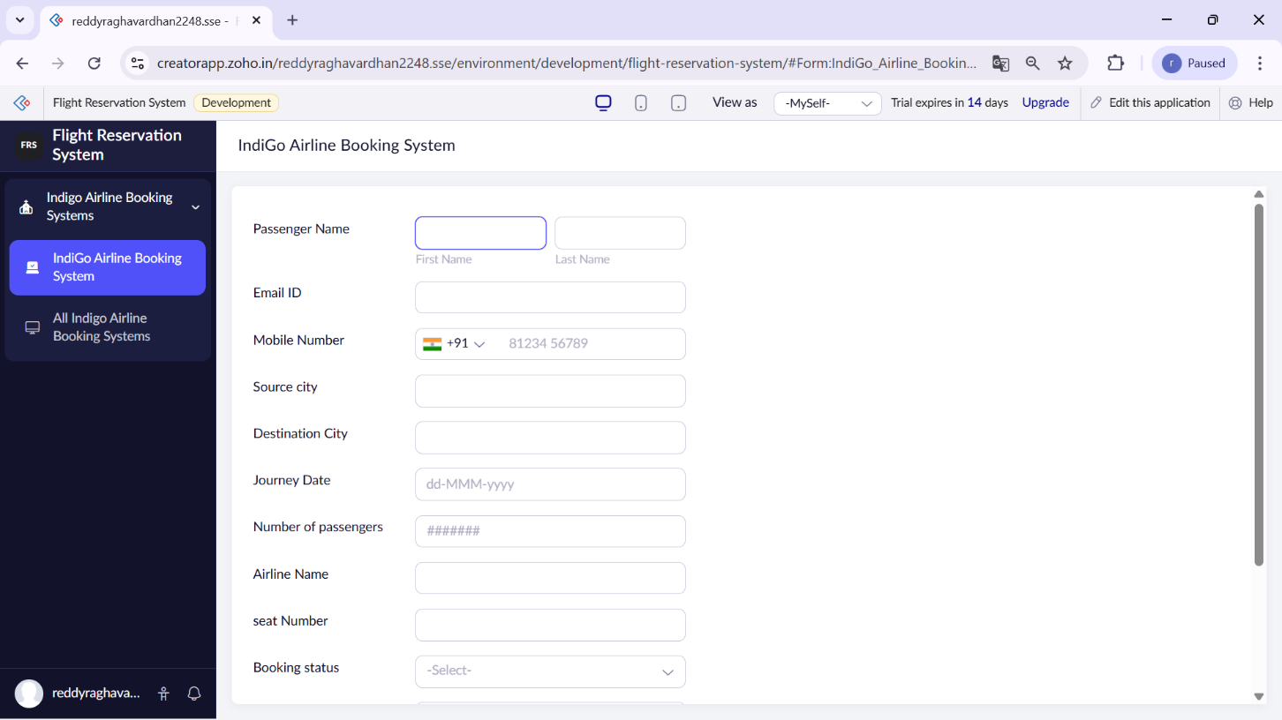

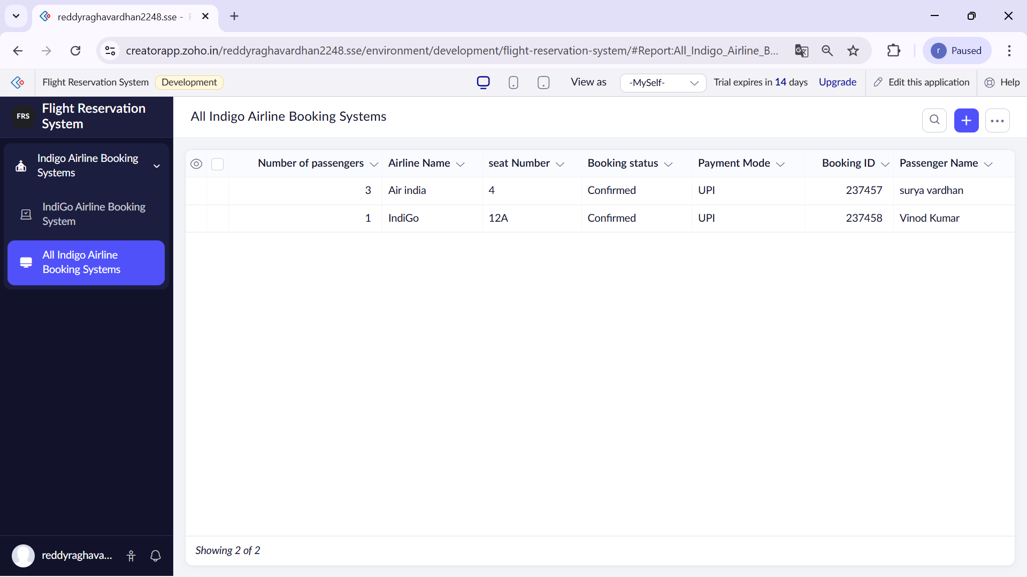

Result:
A simple cloud-based Flight Reservation System was successfully developed and deployed using Zoho Creator. The application was accessible through the internet, allowing users to search flights, book tickets, and view booking details online.

